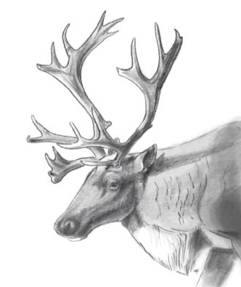

1:00 – 3:00 pm October 27, 2021

MLIB: Lisa Krebs, Maya Stano (Absent: Brian Toth)
BC: Loni Arman, Darcy Peel, Heather Wiebe, Janet Hughes, Brett Hudson (Joined at 1:30 – ENV ADM Jim Standen, FLNR ADM David Muter, FLNR Ryan Bichon)
ECCC: Jaspal Aulakh, Renée Lapointe (Absent: Robin Steenwig)

Action Review
Apr. 14-May 12 | BC to respond to IMA, funding work plan, G2G (not being the mechanism BC wants for agreement) and Sec 11 – 7.2 MOU.  Update – on hold | Bryan W
June 23 | BC to draft a MOU (term sheet) ID headers, parameters, roles, and responsibilities – other provisions to be worked on together  - Will be ready for discussion for July 21st meeting – Did not occur. – on hold until Canada can participate  - Oct 27 update: BC and ECCC to draft a term sheet together prior to presenting to MLIB. BC and ECCC to draft prior to Nov 24th meeting. | BC (Bryan W)
Sept 15 | Funding 50,000 Stob 80 (Shared cost arrangement) in draft will have agreement in coming days.  MLIB (Lisa) to provide brief general overview of where money might be used (ethno/community meeting/etc.)  Linking to Scott’s work, linking to Parsnip LUP  Updates Oct 13:  Lisa will provide an overview to Loni  Restoration -still exploring the restoration –– Scott is working on it and on a call tomorrow with FSJ caribou to discuss road in question  ECCC contribution agreement is being negotiated – Lisa and Agathe in conversations  Update Oct 28:  Lisa will provide overview at next meeting | Loni/Lisa
Oct 27 | David & Jim to have discussion with ministers regarding park management plan and get back to MLIB, | FLNRORD/ Parks
Oct 27 | David & Justin to discuss Parsnip approaches | FLNRORD

ECCC Update:
- Cabinet shuffle. Can now sit back at the table
- BC and Canada to get together on a terms sheet
- A response from BC is still requested by MLIB and an update on the next steps
- Opportunity for BC and ECCC get together ensure a common understanding of how it could work under Section 7 under the Section 11
- Lisa – we are going to have revisit some of the technical presentation – crisis in the Parsnip
- WI in the field and they are doing edits on the report then continue the conversation at some point. Will be part of the interest in context of the agreement
- Lisa will check with WI if they are available next meeting to present again. Would give BC/ECCC to have time to discuss. If next meeting will have an agreement focus that is fine but she wants to get a fulsome presentation on the agenda and have it for distribution and discussion
November 10th Meeting: Loni
- Loni is off, looking for someone else to chair and note-take
- Lisa to confirm if MLIB has agenda items
- WI have deliverables just outside date – Lisa to resubmit a timeline to WI to see if they can commit for the 9th meeting
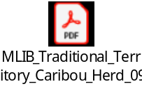
MLIB had a map made for context. 3 TSAs in MLIB and 2 in the Parsnip. 2 herds in parsnip KS and Hart Ranges
Klinse-za Park Expansion
- Overview (provided by Loni):
  - The PA defines certain zones that will be subject to new management designations, Zone B3 is identified as an additional expansion of the Twin Sisters (Klinse-za) Park. It will protect approximately 200,000 hectares in total and is intended to limit disturbance and development in caribou habitat.
  - FLNRORD initiated consultation with MLIB on behalf of BC Parks on May 6, 2021 with an end date of May 21, 2021.
  - In June 2021 MLIB raised concerns with proposed Klinse-za Park expansion to the tripartite (MLIB, British Columbia, and Environment and Climate Change Canada) caribou recovery table. The main issue was procedural, consultation was set at notification level for two weeks, which MLIB deemed as inadequate for a project of this geographic extent.
  - In a follow up meeting MLIB requested that the decision be postponed until there was adequate time for consultation.
  - On July 23, 2021 a third meeting occurred between BC and MLIB. At this meeting MLIB stated that they have Treaty Rights and Aboriginal Rights and Title. They stated that the park would impact their economic rights as they will not be able to harvest within the area, noting concerns about cutting permits, and a spreadsheet with blocks and permits was provided.
  - On October 14, 2021, MLIB provided their Old Growth Strategy for the Mackenzie Timber Supply Area. MLIB’s proposed area for old growth partially overlaps the Klinse-za Park expansion (~31%) and the Partnership Agreement Moratorium area (~10%).
  - Want to understand impacts on MLIB’s Treaty Rights. It is the Province’s opinion it will not impact Treaty Rights, feels as decision has been postponed, and considers consultation is ongoing.

- Lisa: before McLeod Lake responds, asked Heather for caribou #s within the park.
- Heather provided requested data: Approx # of caribou 101 in Klinse-za, also noting the original park boundary covered most of the core range. Access to prime habitat for forage, security, and calving range. Potentially increases the carrying capacity of the herd. Potentially some additional connectivity to the Kennedy Siding herd. Further solidifies the joining of the former Scott East and Moberly herds (now known just as Klinse-Za), and maybe also connectivity to the extirpated Burnt Pine range.
- Lisa: Since April MLIB has been working with SME to understand what the current context of caribou in MLIB. Questions to guide the inquiry were shared w. BC & Canada counterparts - habitat integrity (core & matrix), and future development. Presented initial findings two weeks ago. Important to understand a sort of crisis in the Parsnip. Current stated slide:
- 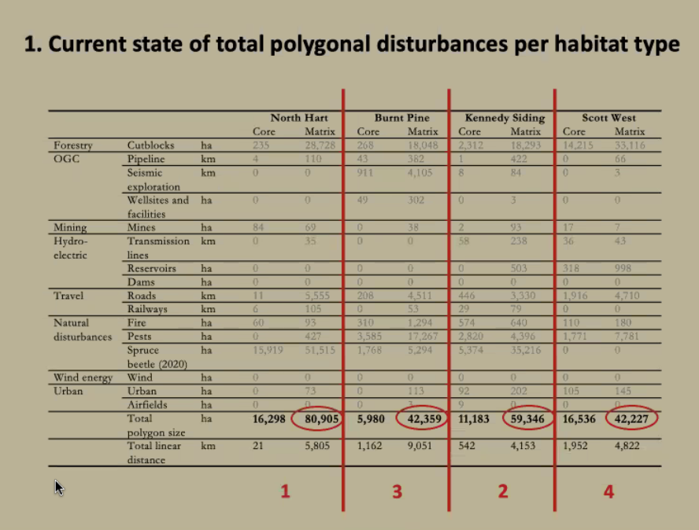
- MLIB’s herds of interest in the LUP context North Hart, Burnt Pine, Kennedy Siding and Scott West.
- 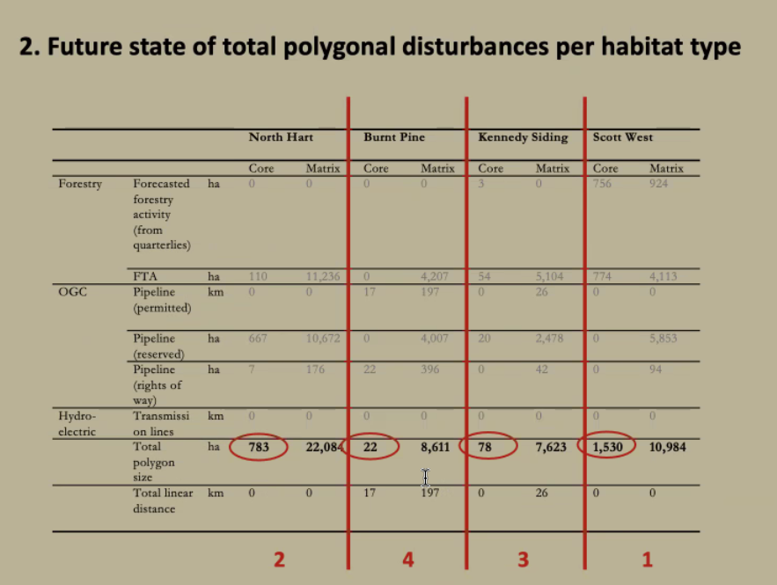
- 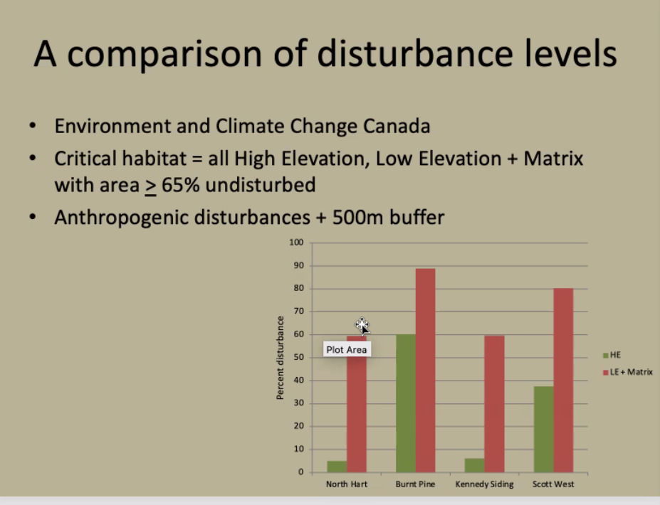
- Will add future impacts onto the graph 9 want to see clearly what this will look like for next 2-3 years
- Park was used in context of Klinse-za herd – extreme tool considering it is caribou recovery for one herd and MLIB have interest. Maintained that expansion is unconstitutional.
- MLIB has both economic and stewardship issues with caribou and intersects with grizzly and moose
- Want to understand co-management arrangement within Klinse-za – does that exist now?
- Also let’s think about Treaty Rights and Section 35 Rights. It’s the federal recovery imperative for self sustaining levels
- Maya – BC draft principles are very clear on rights recognition, even go back to oil & gas consultation agreement (2014?) it talks about S35 rights, as well as Treaty Rights . We need to acknowledge the Section 35 Rights. MLIB holds Treaty and Aboriginal Rights.
- Economic rights – court clear if there are economic benefits they attract the duty to consult.
- Crisis of caribou herds in the Parsnip, would appreciate information on co-management on current park and proposed expansion, comprehensive land management – when you add on additional authorizations that haven’t been shown in Lisa’s graph, we are in a Blueberry River situation.
- ABSA? - Atmospheric benefit sharing agreement. David – there isn’t that opportunity for this one – offsets have to come with something called additionality – this was not the case here. Cannot realize a carbon offset benefit here. To Maya’s point – we’re not done consultation, but want to close off, so want to truly understand the perspective from MLIB on the park expansion. Is hearing MLIB expressing an interest in stewardship and for co-management of caribou – can you tell me more about that.
- Lisa - MLIB looks at park expansion as wow you did this extreme measure to protect 101 caribou…what are you doing to protect our interests in other herds (in the Parsnip where we have this crisis? Where is MLIB able to take a stewardship lead? Last December BC provided concept on Parsnip that might look at an integrated LUP with a caribou anchor.
- David – is the co-management about the Parsnip?
- Lisa - Co-management could certainly start in the Parsnip, then what does it look like to move out. There are other processes at play to the east & west – how do they all fit. Not bounded by the Parsnip, but is the testing ground for where some of these processes could occur.
- Maya – wants to make sure they are not excluded from co-management role
- David – increased stewardship for primary forest health, co-management in the Parsnip but not limited to that, and co-management in the Klinze-sa.
- Concerns of lost of jurisdiction
- Brett - if park were to be established, there are no co-management arrangements currently but there is a commitment to explore future co-management arrangements, would be involving MLIB on how the park is management
- Lisa – what form of exploration? how would MLIB be involved? Through consultation?
- Maya- Would be helpful for MLIB to have certainty on the role
- David – the PA doesn’t give management authority to WMFN or SFN, but should the park expansion go forward there is an opportunity that the provincial government can consider, but it would be a Cabinet level discussion.
- Jim - Nothing has been predetermined in the potential co-management conversation
- Maya- looking for certainty – is this the point to develop term sheets or something?
- David – You are asking if now is the time to put something down on paper as to what that looks like. Not sure. Probably need to go back to our respective ministers to provide an understanding and get some options we can bring back. This will require fleshing out what species, habitat and objectives – on park management side, different models of how this could work on governance/co-management.
- Maya – can we get confirmation a decision won’t be made on the expansion until more information is provided
- David – cannot say what Ministers may decide/timing
- Maya – understand MLIB considers consultation is not complete
- David – confirms this understanding, commits to working on this, will let this group know timeline
- Lisa – wants to go back to Parsnip concept as well – where are we with this – start conversation about MLIB to start that integrated planning process – not just for caribou but for other stewardship interests
- David – that sounds really, really good to me. Land use planning approach is fairly intensive approach. Can be governance-heavy. There are other ways to achieve that shared stewardship management – Justin Calof of FLNR North Area. is aware of other options. Is hearing MLIB wants more on stewardship, wants more on improving outcomes for wildlife, concerns with forest health. David to discuss with Justin
- Loni – David & Jim to have discussion with ministers and get back to MLIB, David & Justin to discuss Parsnip approaches.
- Lisa – to provide map she had shown at start of meeting 
- Re: next meeting – Lisa to confirm availability of new info – possible to cancel if timing doesn’t work for new info to be ready.

